Excel Milestone Project
Walmart Sales Dataset
DATA ANALYTICS BATCH sep2025
REFERENCE : www.kaggle.com Presented by: Navin. S



TABLE OF CONTENTS
- Introduction
- Formulas and Functions
Charts and Dashboards
- What-If Analysis and Goal Seek
- Macros
- Power Query
- Findings
- Conclusion
- Recommendations

1. INTRODUCTION
Microsoft Excel is one of the most widely used analytical tools in business, education, finance, and data-driven environments. Modern Excel goes far beyond basic spreadsheets; it includes advanced features such as formulas, dashboards, automation through macros, and powerful tools like Power Query and Power Pivot.
This project provides a comprehensive analysis of several advanced Excel capabilities:
- Formulas and Functions
- Charts and Dashboards
- What-If Analysis and Goal Seek
- Macros
- Power Query
- Power Pivot
The report examines how each tool works, where it is used, and how it contributes to better data analysis, decision making, and business productivity.

DETAILED ANALYSIS

2.1 FORMULAS AND FUNCTIONS

Overview
Formulas and functions form the foundation of Excel’s computational abilities. They help users perform calculations, analyze data, automate logic, and manipulate text and numbers.

Key Types of Functions

A. Mathematical Functions
- SUM(), AVERAGE(), COUNT(), MAX(), MIN()

B. Logical Functions
- IF(), AND(), OR(), NOT(), IFS()

C. Lookup & Reference

Importance
- Helps in calculations
- Data cleaning
here is the dataset description given as clear point-by-point items:
1. Date – Shows the week of the sales
2. Weekly Sales – Total sales made in that particular week.
3. Holiday Flag – Indicates if the week includes a holiday/festival (1 = Holiday, 0 = Normal week).
4. Temperature – Weather temperature for that week.
5. Fuel Price – Fuel cost during that week
6. CPI (Consumer Price Index) – Shows price level and inflation trends.
7. Unemployment Rate – Shows economic condition based on employment levels.



DATA SET CALCULATION

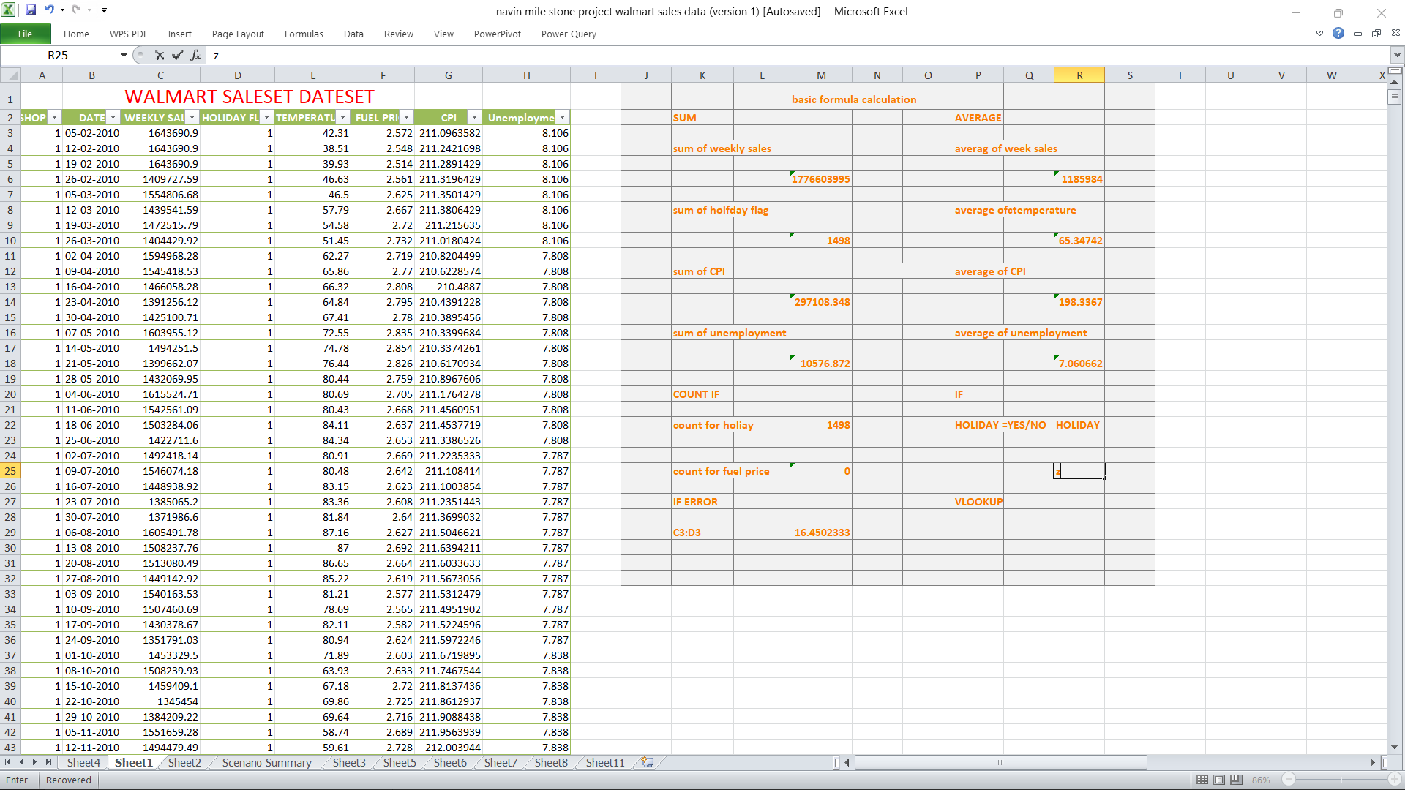

2.2 CHARTS AND DASHBOARDS

Overview
Charts and dashboards convert raw data into meaningful visual insights. Dashboards enable interactive reporting, helping managers track KPIs, trends, and performance indicators.

Importance
Dashboards provide:

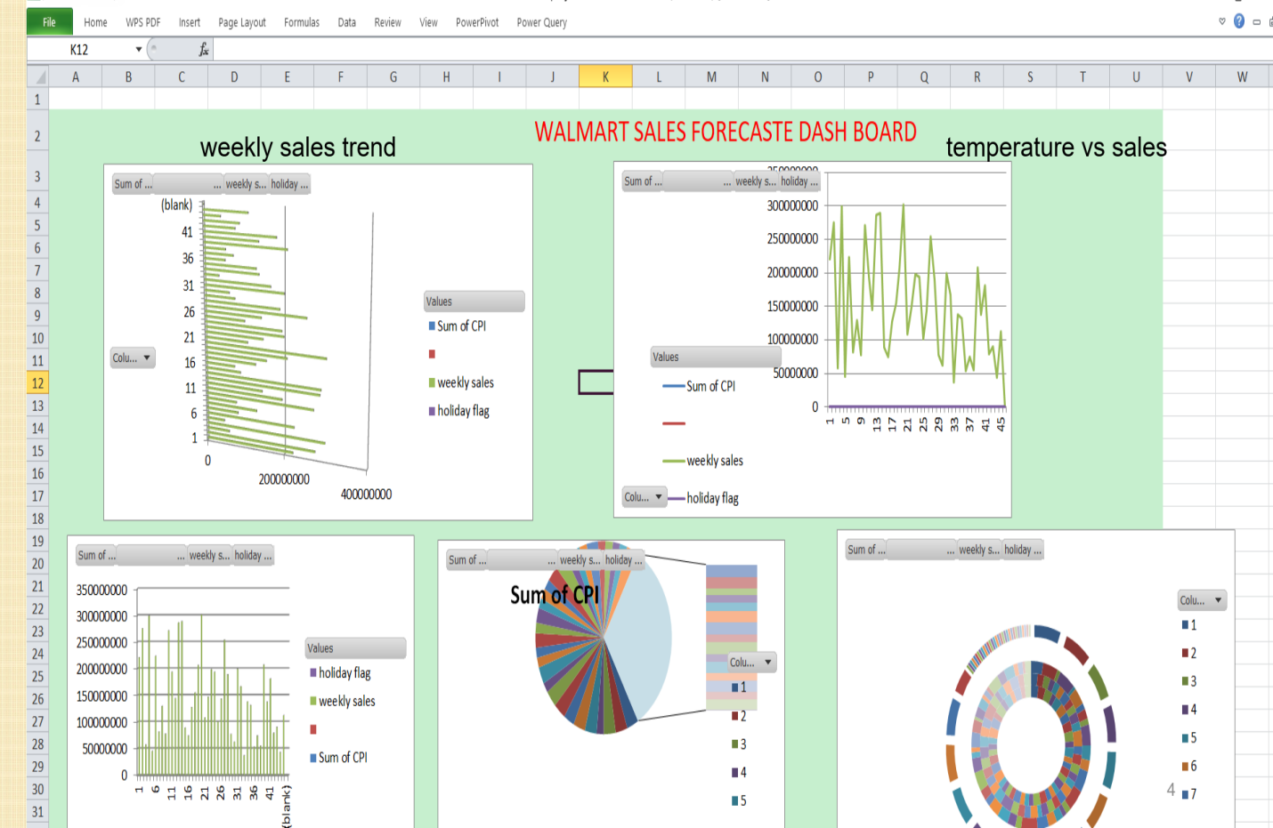Importance
Dashboards provide:
- Real-time insights
- Professional reporting
- Improved communication of complex data

. WHAT-IF ANALYSIS & GOAL SEEK

3.1 Definition
What-If Analysis allows users to test how changes in input values affect outcomes.

3.2 Tools in What-If Analysis

A. Scenario Manager
Create and compare multiple scenarios:
- Best Case
- Worst Case
- Expected Case

Shows results side by side.

A. Scenario Manager
Create and compare multiple scenarios:
- Best Case
- Worst Case
- Expected Case
Shows results side by side.
BENEFITS OF WHAT-IF ANALYSIS FOR REPORTS
Use these points directly in reports
1. Helps in Decision Making
You can test different assuptions and quickly see how results change.
(Example: If cost increases 10%, how does profit change?)
2. Saves Time
No need to calculate manually for every scenario. Excel instantly changes all values.
3. Shows Best-Case & Worst-Case
Helps present different scenarios (e.g., Sales ↑, Sales ↓, Market Change).
4. Reduces Errors
Once formulas are set, Excel calculates everything accurately.
5. Makes Reports Professional
Adding scenario outputs makes your report analytical and data-driven.
6. Helps Forecasting
Useful in budgeting, finance planning, pricing strategy, and target analysis.

---

GOAL SEEK – Meaning + Benefits
Meaning
Goal Seek finds what input value is required to reach a desired output.
Example
If Profit = Sales – Cost
You want Profit = 100,000
Goal Seek will find the required Sales value
BENEFITS OF GOAL SEEK FOR REPORTS
Us these points in project reports / dashboards:
1. Target-Based Planning
Helps calculate:
Required sales to reach target profit

- Set "By changing" → sales cell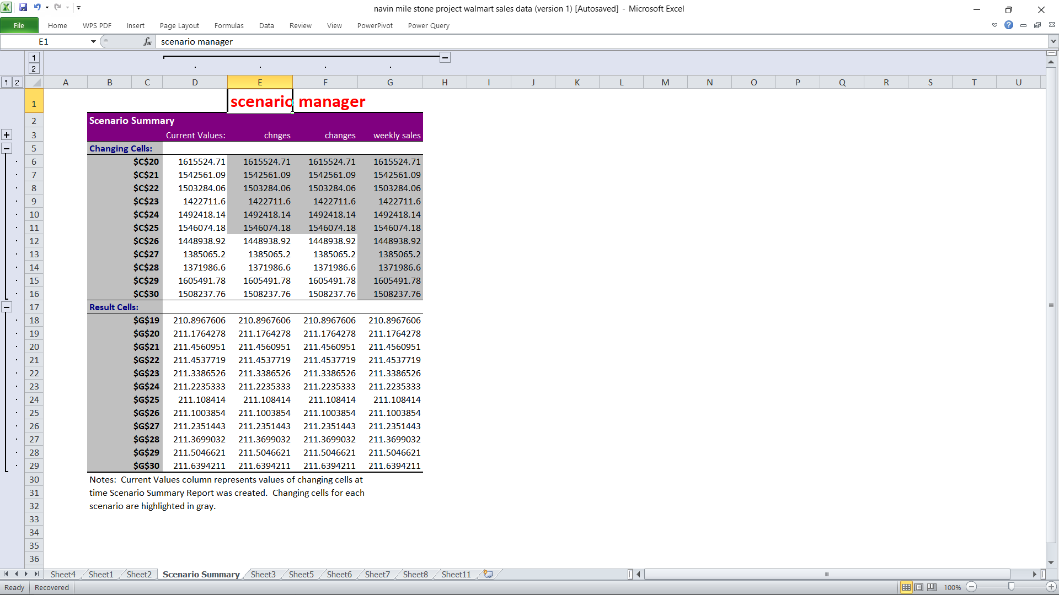

C. Goal Seek
Used to determine what input value produces a desired output.
Example:
You want profit = $50,000.
Goal Seek will calculate the required sales.
Steps:
- Data → What-If Analysis → Goal Seek
- Set "Set cell" → total profit cell
- Set "To value" → 50000
- Set "By changing" → sales cell

. MACROS

4.1 Overview
A Macro automates repetitive tasks using recorded actions or VBA code.

4.2 Recording a Macro
- Enable Developer Tab
- Click Record Macro
- Perform tasks
Click Stop RecordingExcel saves your actions as code.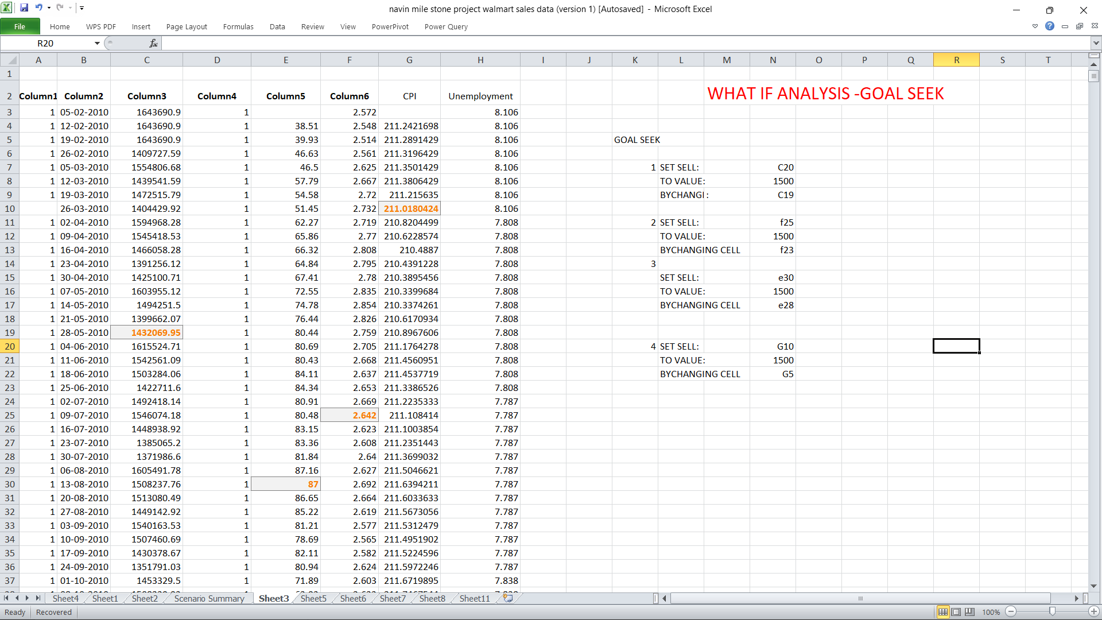

Excel saves your actions as code

.

.

.
y.

. 5. Power Query

A. What It Does
Power Query helps you import, clean, transform, and combine data automatically.

B. Key Functions
- Remove duplicates
- Split columns
- Merge / Append queries
- Unpivot data
- Load data into Excel or Data Model

C. Best For
- Replacing complex formulas
- Building automated ETL pipelines
- Cleaning messy files (CSV, PDF, web data)

Key Functions
- Remove duplicates
- Split columns
- Merge / Append queries
- Unpivot data
- Load data into Excel or Data Model

C. Best For
- Replacing complex formulas
- Building automated ETL pipelines
- Cleaning messy files (CSV, PDF, web data)
- Cleaning messy files (CSV, PDF, web data)
- 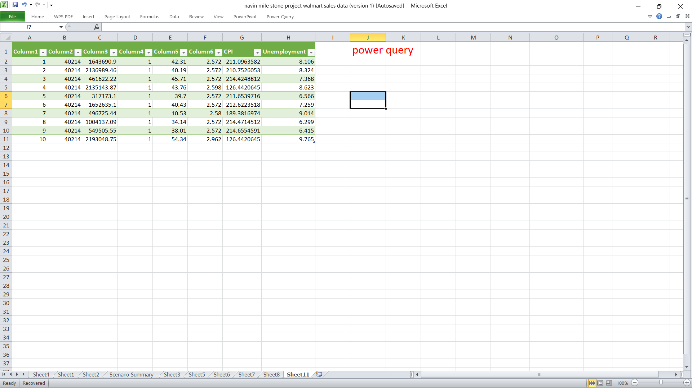

6. Power Pivot

A. Purpose
- Advanced data modeling
- Works with large datasets
- Creates relationships between tables
- Adds advanced DAX calculations

B. Key Concepts
- Data Model
- Relationships (similar to databases)
- DAX Functions (like formulas for mode

1. .

FINDINGS

From the analysis of the above Excel tools, the following findings were identified:Excel’s advanced features significantly improve business productivity.

Users can automate tasks, reduce manual errors, and perform complex analyses.

1. Formulas and functions remain the essential building blocks for all types of calculations and analytics.

2. Dashboards allow businesses to monitor performance in real-time, making data-driven decisions faster and easier.

3. What-If Analysis and Goal Seek are powerful forecasting techniques, especially in financial modeling and budgeting.

4. Macros reduce repetitive work drastically, improving accuracy and saving time.

5. Power Query and Power Pivot transform Excel into a BI (Business Intelligence) tool, capable of handling large datasets and advanced reporting.
- Power Query for data loading
- Power Pivot for calculations

Excel’s advanced features significantly improve business productivity.

Users can automate tasks, reduce manual errors, and perform complex analyses.2. Formulas and functions remain the essential building blocks for all types of calculations and analytics.

3. Dashboards allow businesses to monitor performance in real-time, making data-driven decisions faster and easier.

4. What-If Analysis and Goal Seek are powerful forecasting techniques, especially in financial modeling and budgeting.

5. Macros reduce repetitive work drastically, improving accuracy and saving time.

6. Power Query and Power Pivot transform Excel into a BI (Business Intelligence) tool, capable of handling large datasets and advanced reporting.

CONCLUSION
This project demonstrates that Microsoft Excel is not just a spreadsheet tool but a complete analytical platform equipped with powerful features. Advanced capabilities such as Power Query, Power Pivot, Macros, and dashboards can automate processes, provide deep insights, and support strategic decision-making.
Organizations that fully utilize these tools can greatly enhance their productivity, improve data accuracy, and create advanced reporting systems without needing expensive external software.

